**ACAM – DD Form 2875 Instructions & Explanation**

Instructions for completing DD Form 2875:

1. Fill in all required information

Note: If the link to download ACAM is not received via email within 5 business days, then please contact Solutio Environmental, Inc. at (210) 749-7000

1. The Government Air Quality representative for the facility will complete boxes 18, 18a, and 18b.
2. Send the completed form for approval to [ACAM@solutioenv.com](mailto:ACAM@solutioenv.com) and CC the following:

Frank Castaneda, III, P.E., GS-14, DAF

HQ AFCEC/CZTQ; Air Quality Subject Matter Expert

Email: [francisco.castaneda@us.af.mil](mailto:francisco.castaneda@us.af.mil)

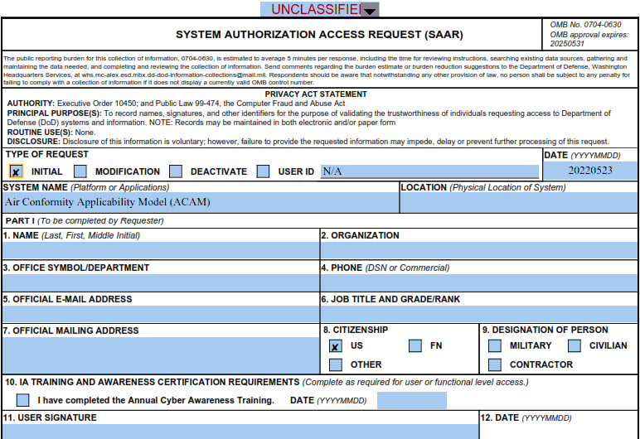

Contractors should enter “Contractor”

Must include Date of request.

Enter Organization or Company Name here.

Not required if ACAM will not be used on a government computer.

**ACAM – DD Form 2875 Instructions & Explanation (cont.)**

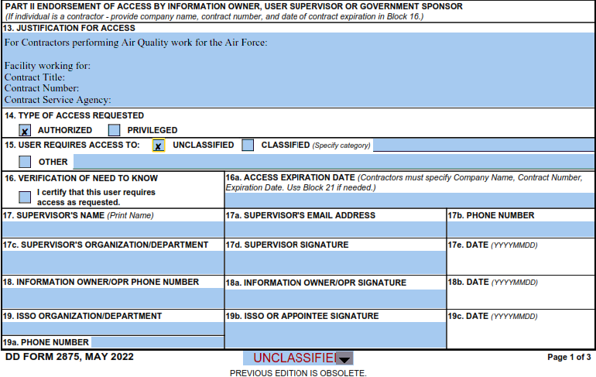

Provide detailed justification.

ACAM PMO representative will sign here after you have submitted your request.

The Air Quality government representative of the facility who is responsible for ACAM must be the one who authorizes you access to ACAM by completing blocks: 18, 18a, 18b. Completed by SME, Frank Castaneda.

Contractors enter their company name here.

**ACAM – DD Form 2875 Instructions & Explanation (cont.)**

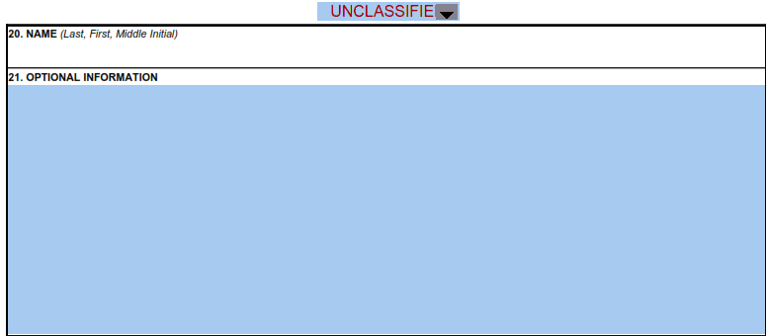

No information needs to be entered in fields 20 and 21

**ACAM – DD Form 2875 Instructions & Explanation (cont.)**

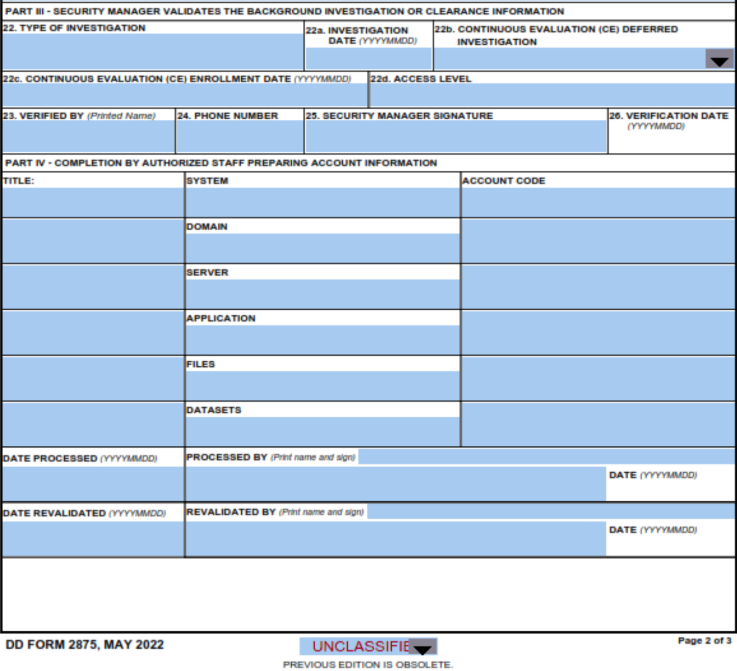

Applicants are not required to complete part III or part IV.